Phase 4 Reply：

there is a score tie and distance tie, then I will choose hospital A/B/C according to the alphabetical order.

Scheduler can send a request to the available Hospitals.

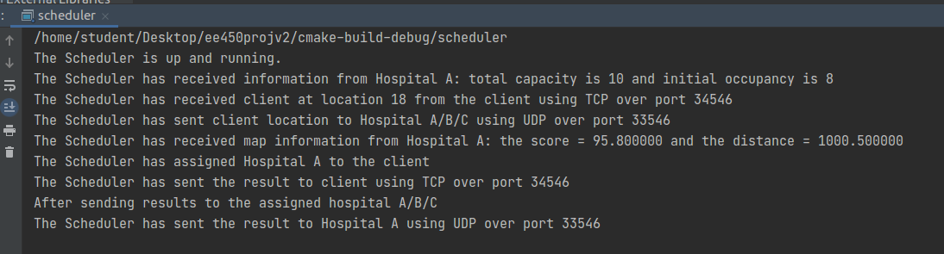

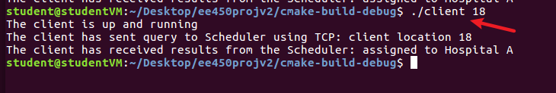

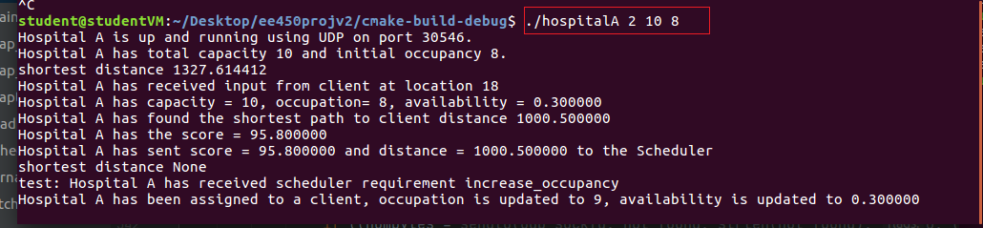

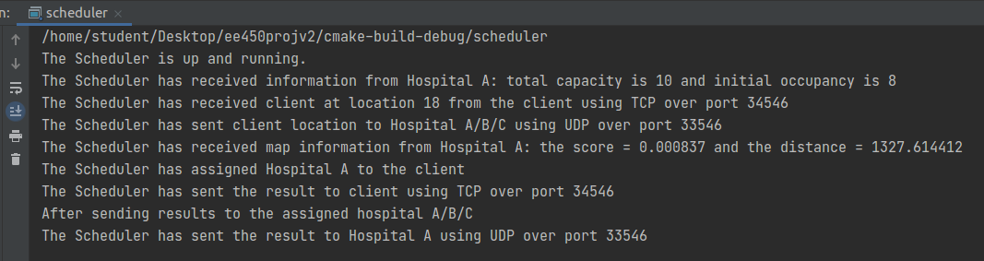

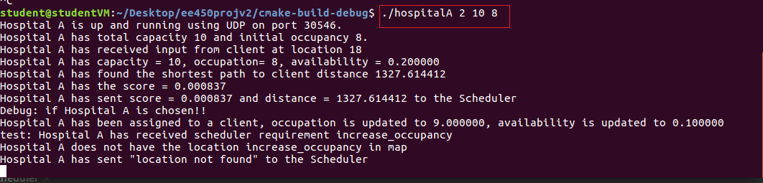

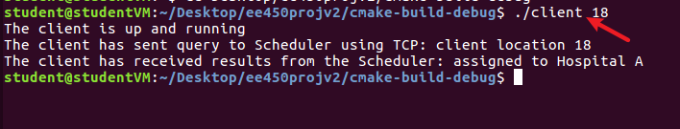

# 输入location有问题

1. L is in the map:

a. L is not the same as hospital location: the distance is the value of shortest

path;

b. L is the same as hospital location (d=0): the distance is ​None​;

./hospitalA 2 10 8

./client 2

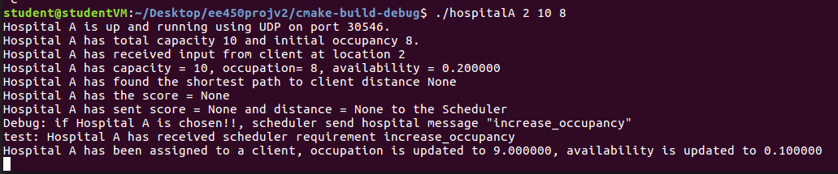

2. L is not in the map: the distance is ​None​.

./hospitalA 2 10 8

./client 3

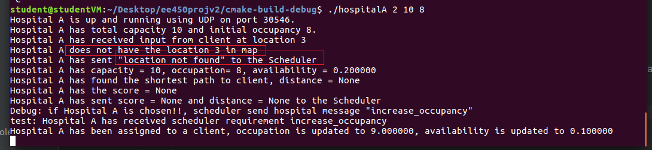

Concerning the availability a, consider the following cases:

1. ​a>=0​ and ​a<=1​: use the availability ​= a​;

2. ​a<0​ or ​a>1​: availability​ = None​;

Concerning the final score:

1. If either availability = ​None​ or distance = ​None​, then the score = ​None

2. Otherwise, compute the score using the defined equation.

./hospitalA 2 10 20

./client 18

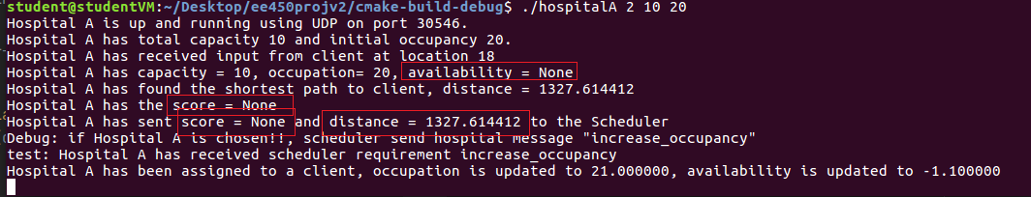

# 正常情况

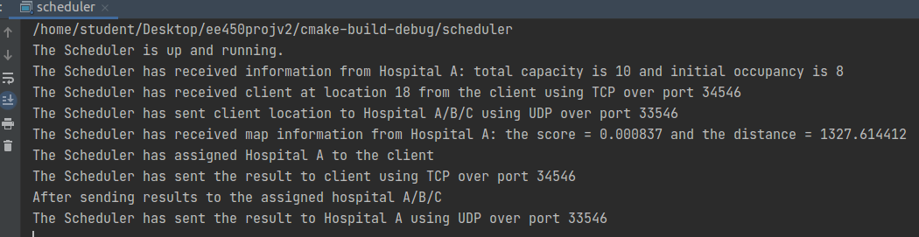

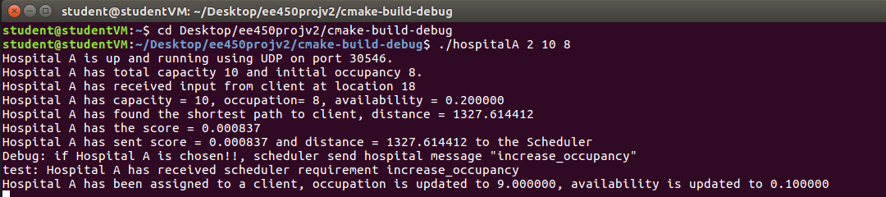

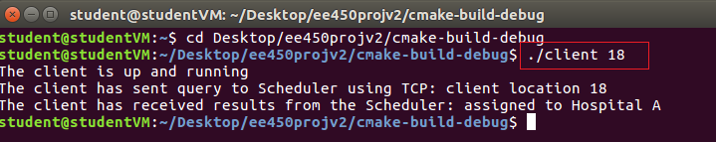

# 三个一起运行！

./hospitalA 2 10 8

./client 18

* distance = 1327.6144116150435

./hospitalB 8 12 8

./client 18

* distance = 1247.55243249362

./hospitalC 14 15 8

./client 18

When all three hospitals are fully occupied, after the client sends its location to the scheduler, the scheduler would reply "None" to the client directly. In this case, we cannot tell if the pisiton of the client is in the map. So even the client's position isn't in the map, the on screen message of the client would be "Score = None, No assignment", rather than "Location <vertex index> not found". Is that right?

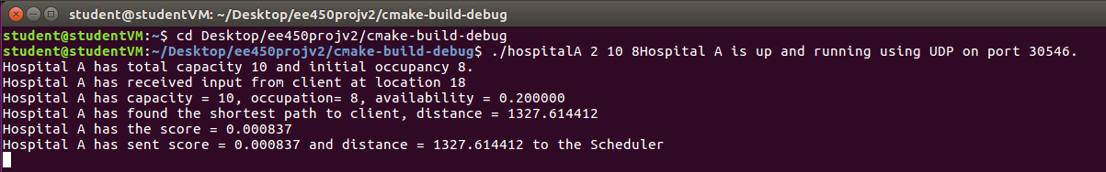

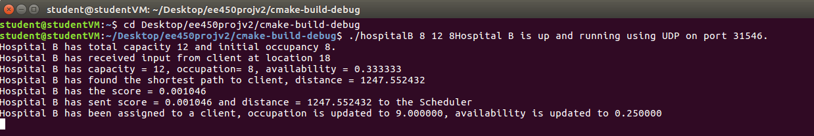

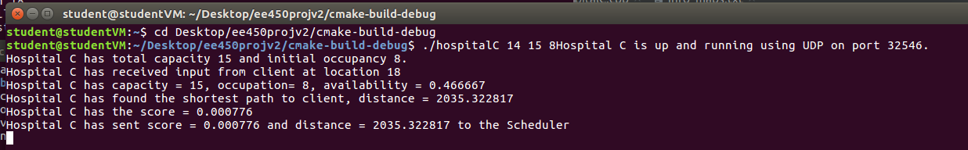

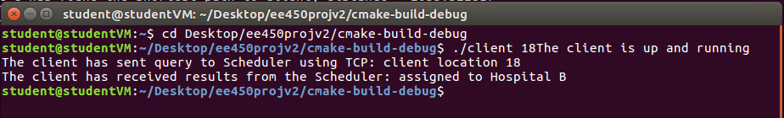

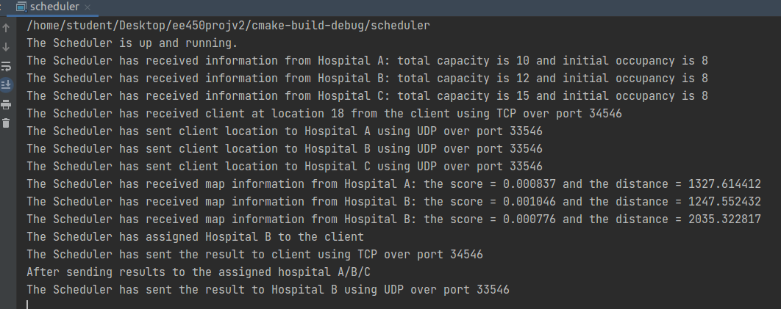

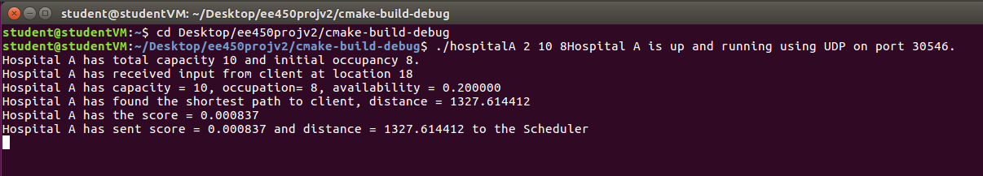

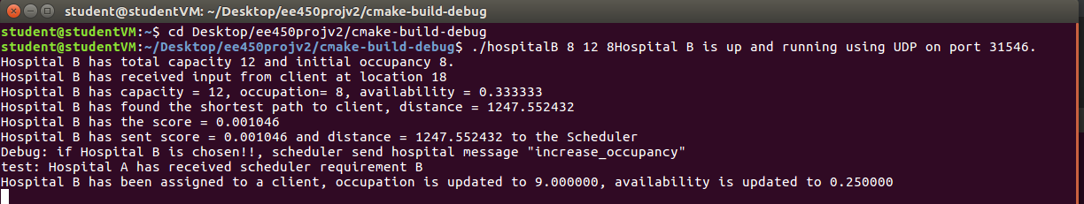

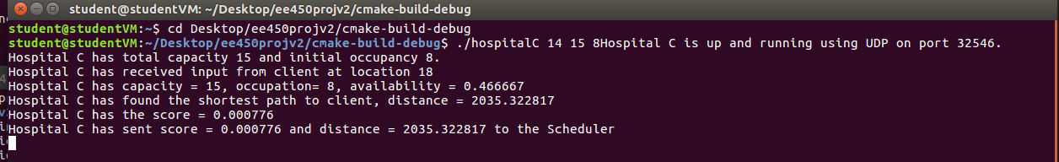

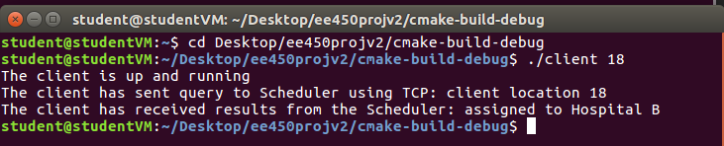

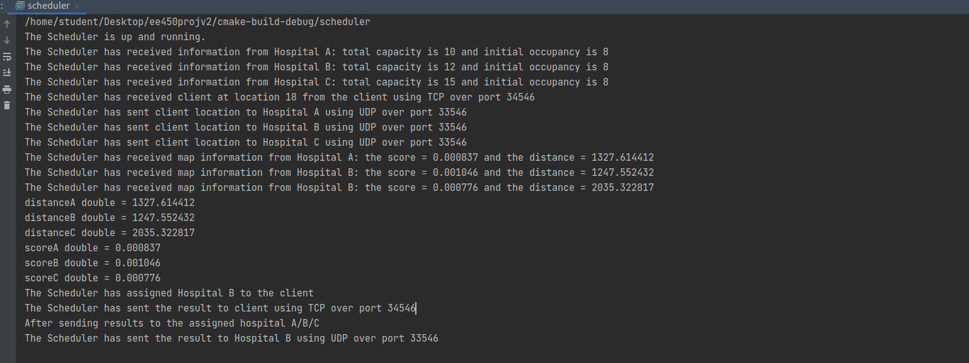

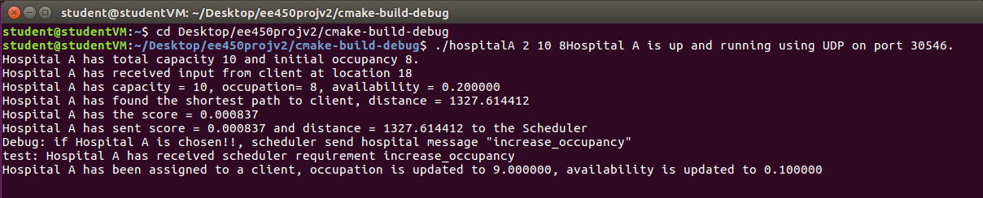

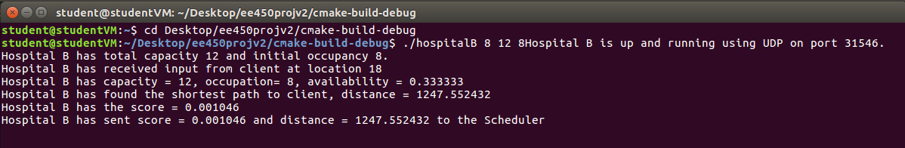

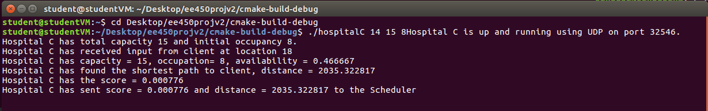

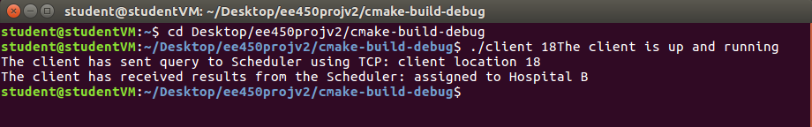

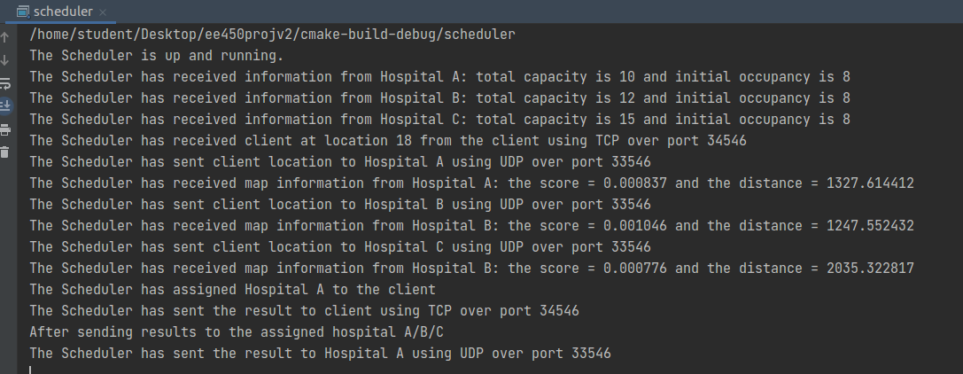

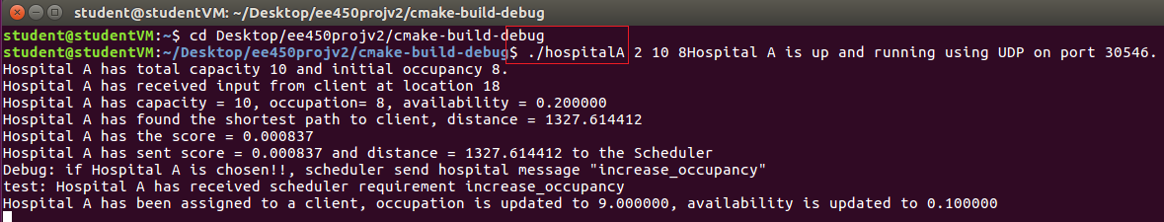

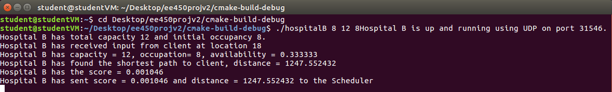

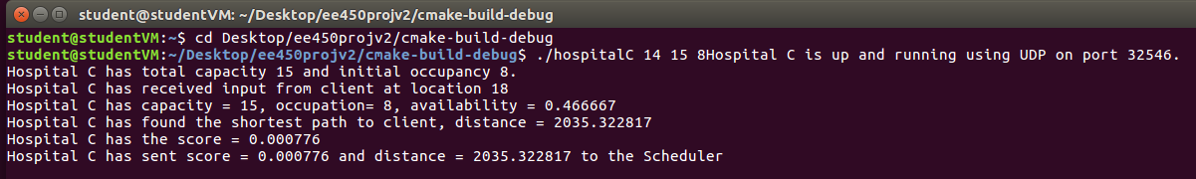

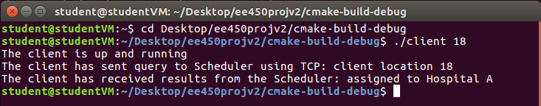

# 正常测试

cd Desktop/ee450projv2/cmake-build-debug

cd Desktop/finalV3

./scheduler

./hospitalA 2 10 8

* distance = 1327.6144116150435

./hospitalB 8 12 8

* distance = 1247.55243249362

./hospitalC 14 13 8

./client 18

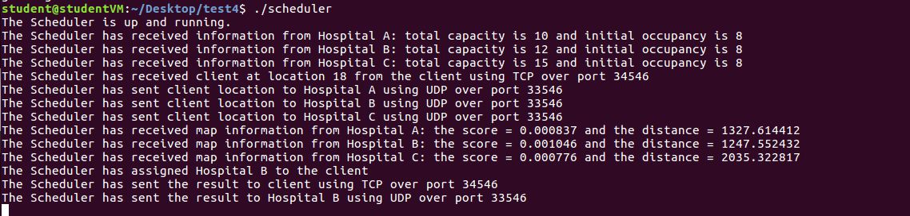

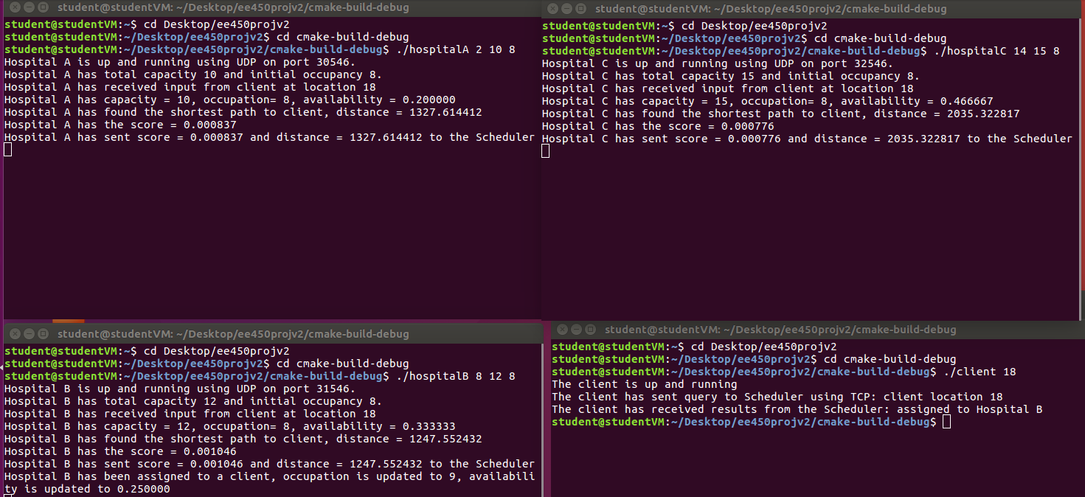

cd Desktop/test4

cd Desktop/finalV3

./scheduler

./hospitalA 255720539 10 8

* distance = 191.12740059516474

./hospitalB 545531658 12 8

* distance = 274.77711078595337

./hospitalC 919573377 15 8

* distance = 170.616152

./client 515154016

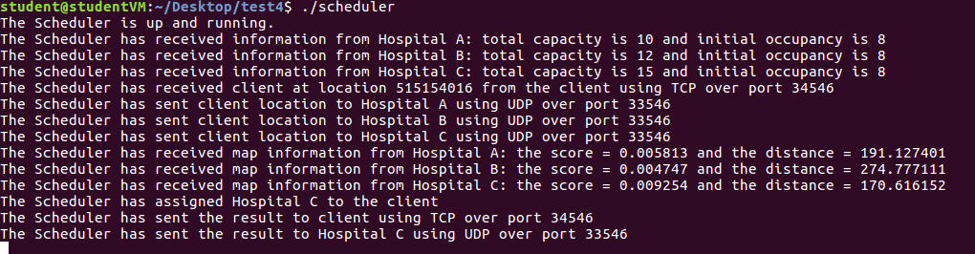

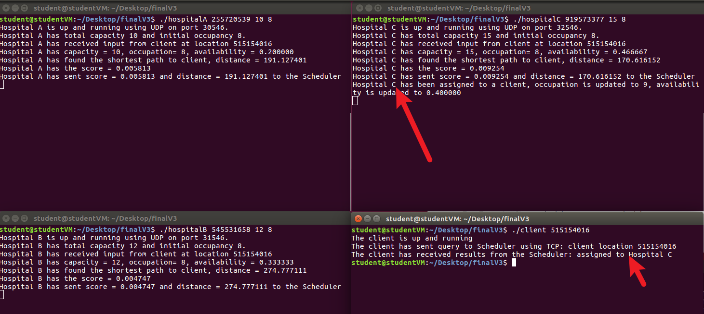

# client location err

## error 1: client not in map

./scheduler

./hospitalA 2 10 8

* distance = 1327.6144116150435

./hospitalB 8 12 8

* distance = 1247.55243249362

./hospitalC 14 15 8

./client 3

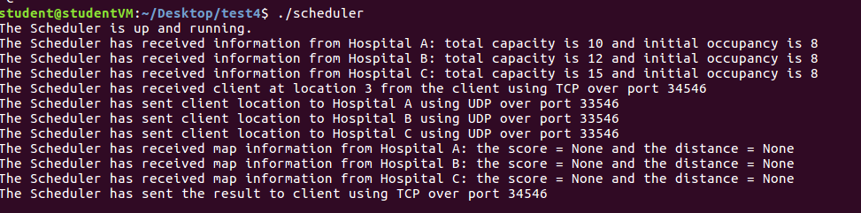

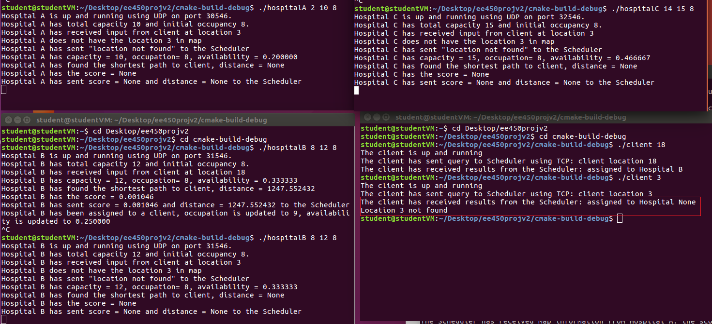

./scheduler

./hospitalA 255720539 10 8

* distance = 191.12740059516474

./hospitalB 545531658 12 8

* distance = 274.77711078595337

./hospitalC 919573377 15 8

* distance = 170.616152

./client 11111

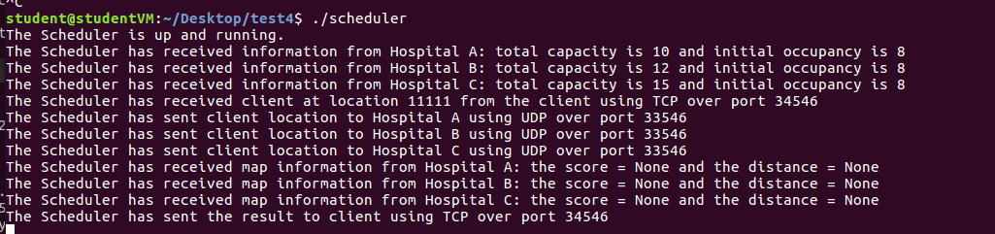

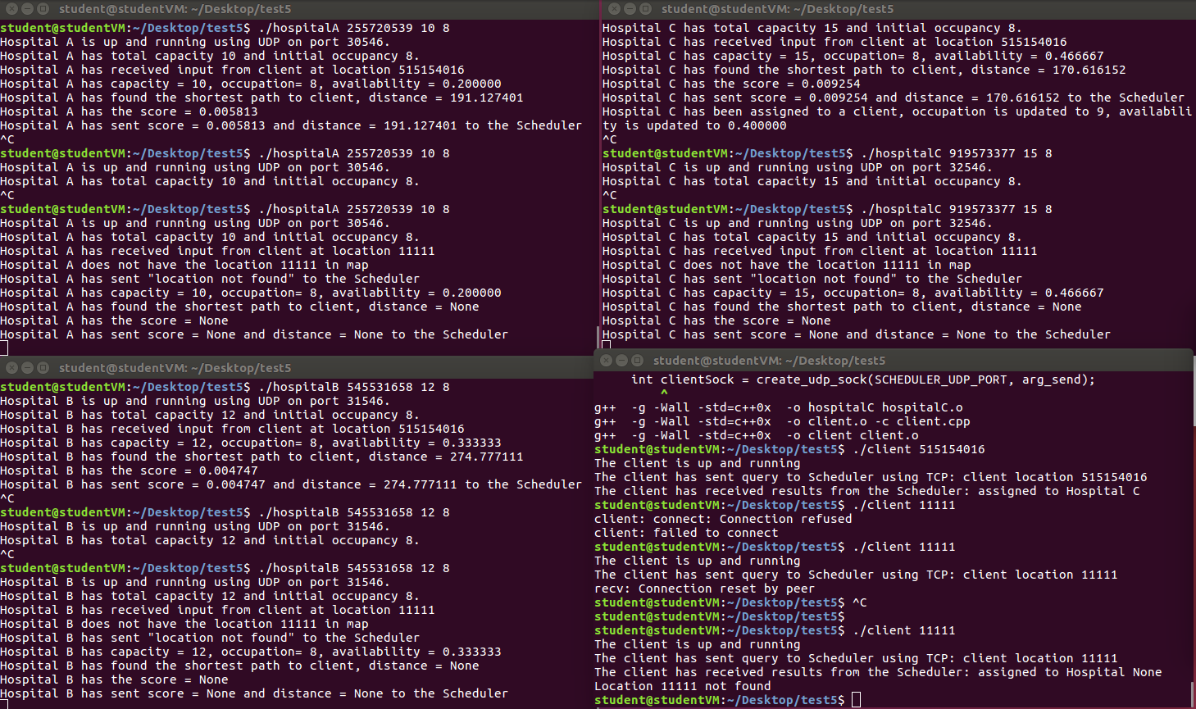

## error 2: L is the same as hospital location (d=0): the distance is ​None​

./scheduler

./hospitalA 2 10 8

* distance = 1327.6144116150435

./hospitalB 8 12 8

* distance = 1247.55243249362

./hospitalC 14 15 8

./client 2

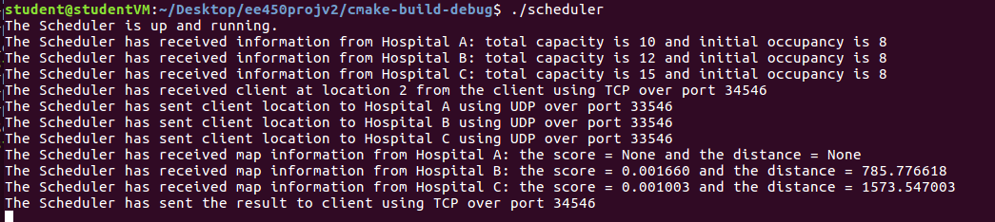

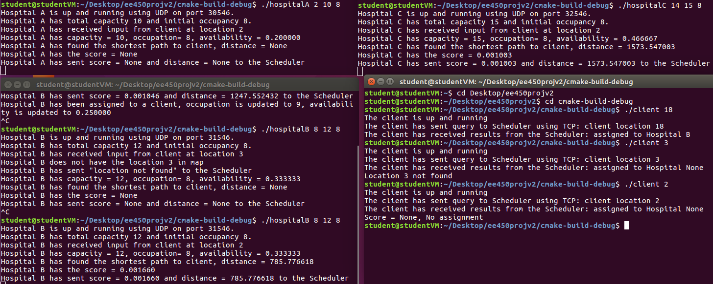

./scheduler

./hospitalA 255720539 10 8

* distance = 191.12740059516474

./hospitalB 545531658 12 8

* distance = 274.77711078595337

./hospitalC 919573377 15 8

* distance = 170.616152

./client 255720539

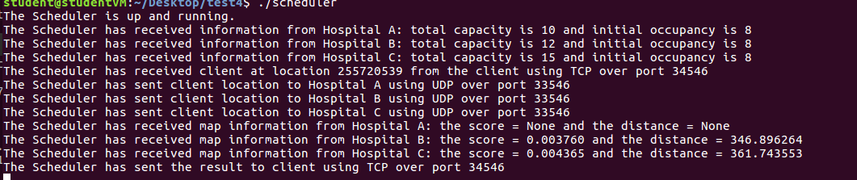

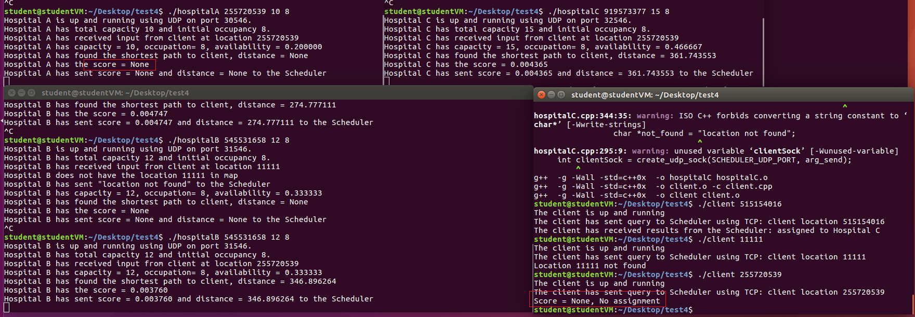

## error availability of A

./hospitalA 2 10 20

* distance = 1327.6144116150435

./hospitalB 8 12 8

* distance = 1247.55243249362

./hospitalC 14 15 8

./client 18

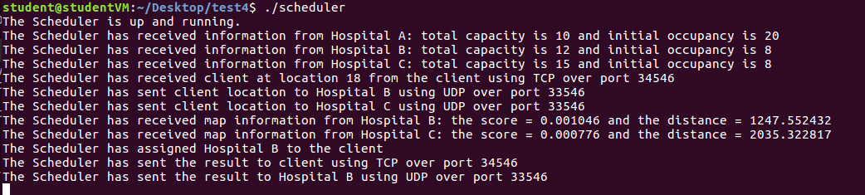

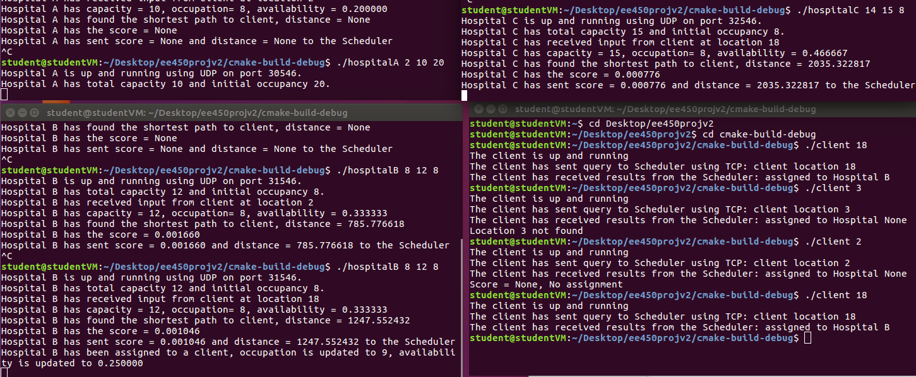

./scheduler

./hospitalA 255720539 10 20

* distance = 191.12740059516474

./hospitalB 545531658 12 8

* distance = 274.77711078595337

./hospitalC 919573377 15 8

* distance = 170.616152

./client 515154016

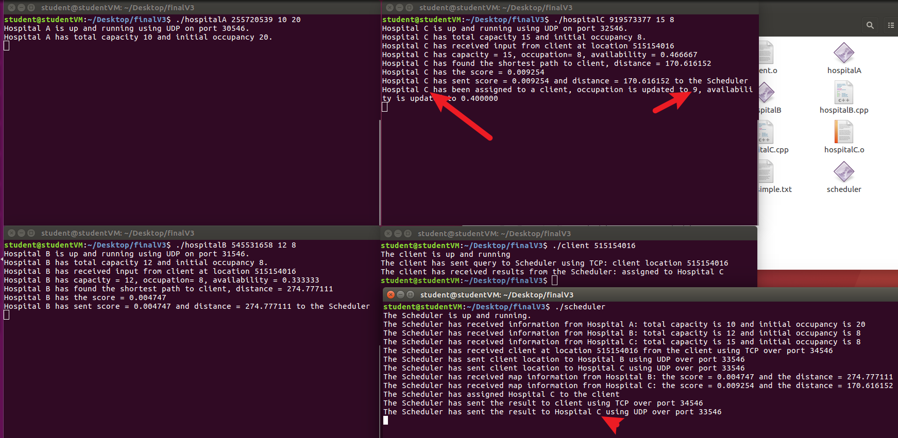

## If all scores == None, reply None.

./scheduler

./hospitalA 2 10 20

* distance = 1327.6144116150435

./hospitalB 8 12 22

* distance = 1247.55243249362

./hospitalC 14 15 25

./client 18

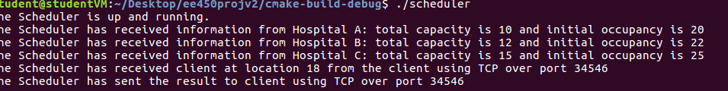

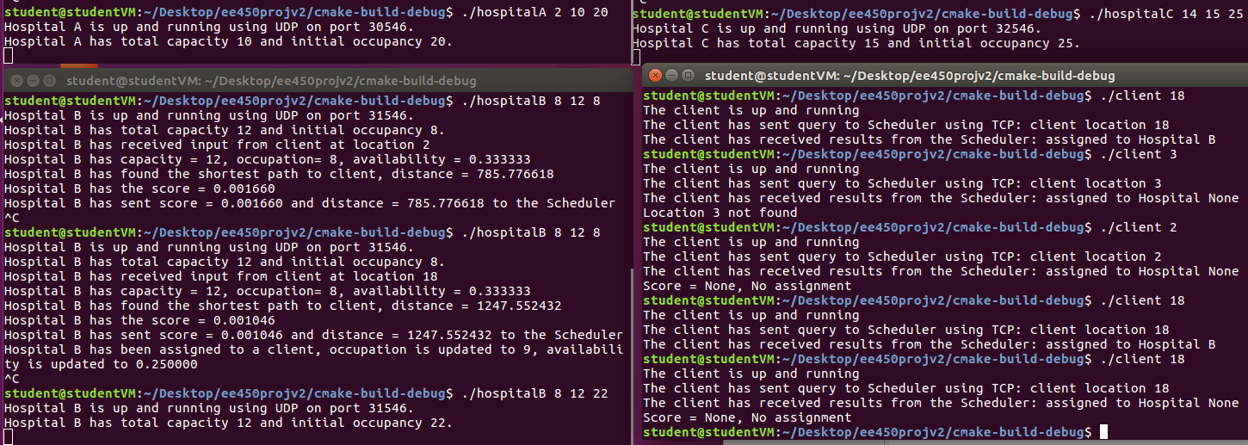

./scheduler

./hospitalA 255720539 10 20

* distance = 191.12740059516474

./hospitalB 545531658 12 22

* distance = 274.77711078595337

./hospitalC 919573377 15 25

* distance = 170.616152

./client 515154016

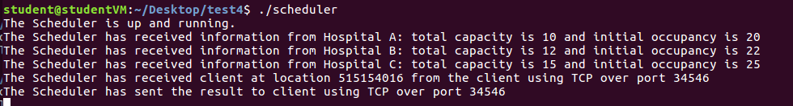

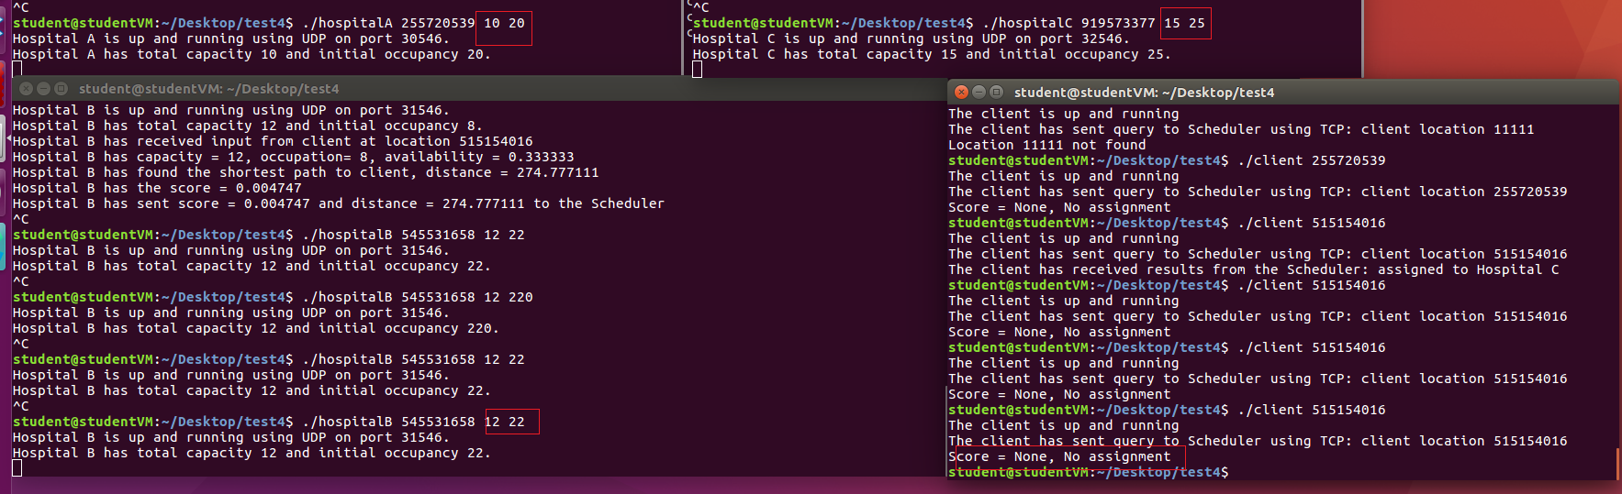

# Multiply query

cd Desktop/ee450projv2/cmake-build-debug

cd Desktop/finalV2

./scheduler

./hospitalA 2 10 9

* distance = 1327.6144116150435

./hospitalB 8 12 11

* distance = 1247.55243249362

./hospitalC 14 13 12

./client 18

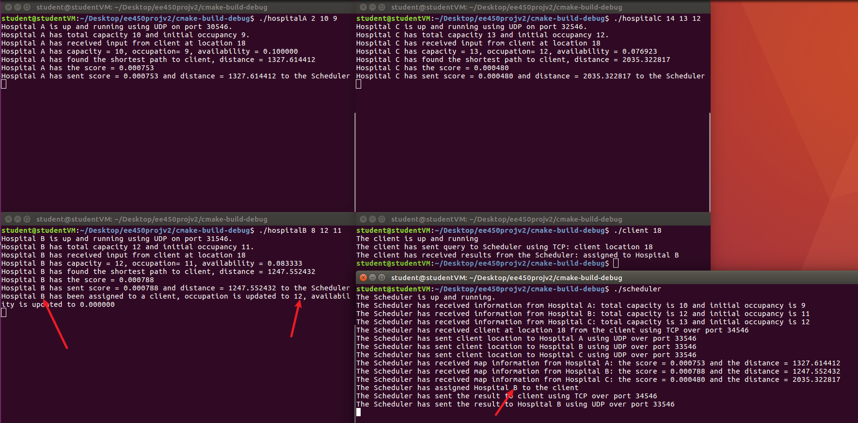

## Debug2

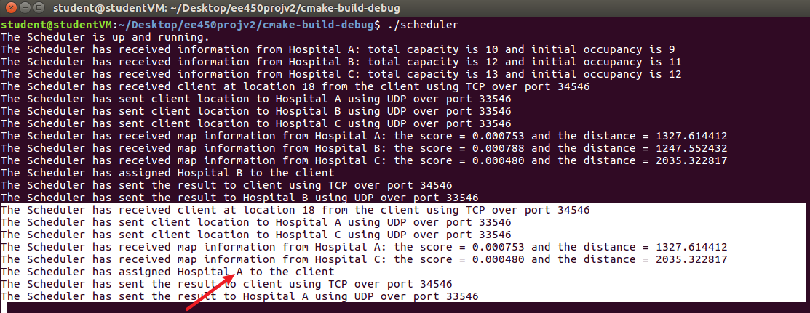

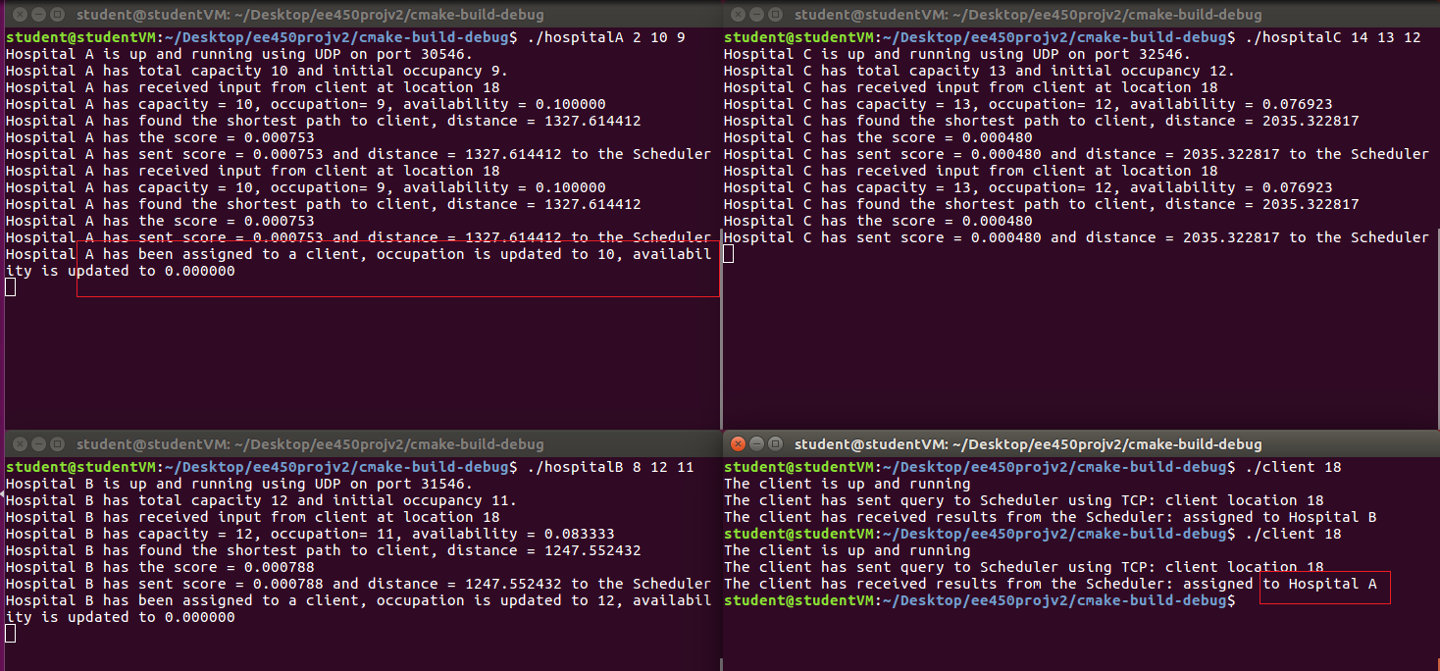

## Debug3

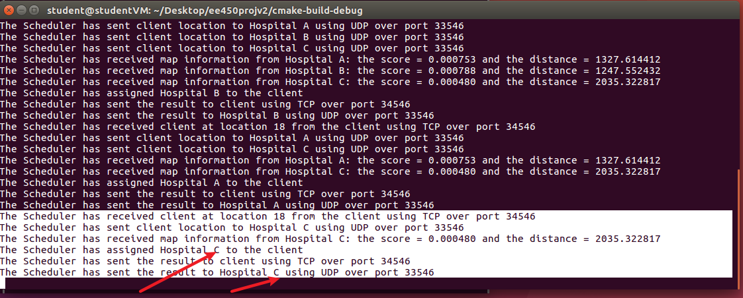

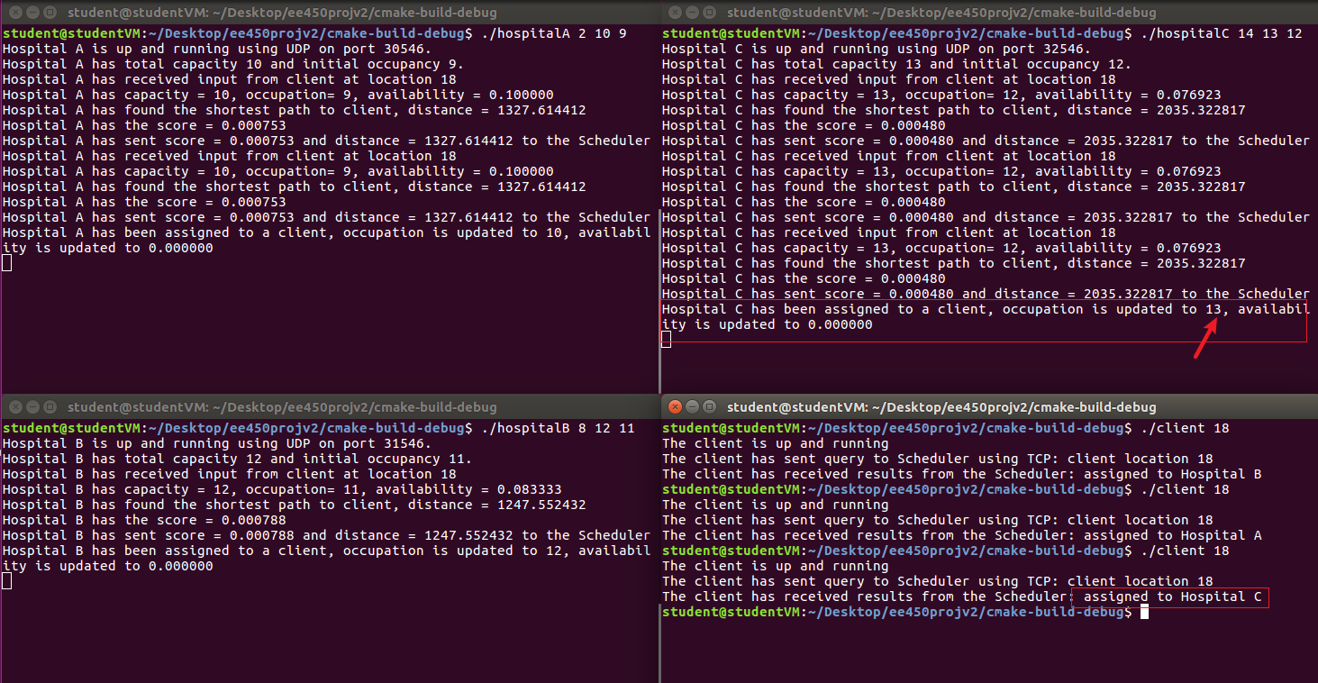

## Debug4



# Multiply query 2

## Debug2

./scheduler

./hospitalA 255720539 10 9

* distance = 191.12740059516474

./hospitalB 545531658 12 11

* distance = 274.77711078595337

./hospitalC 919573377 13 12

* distance = 170.616152

./client 515154016

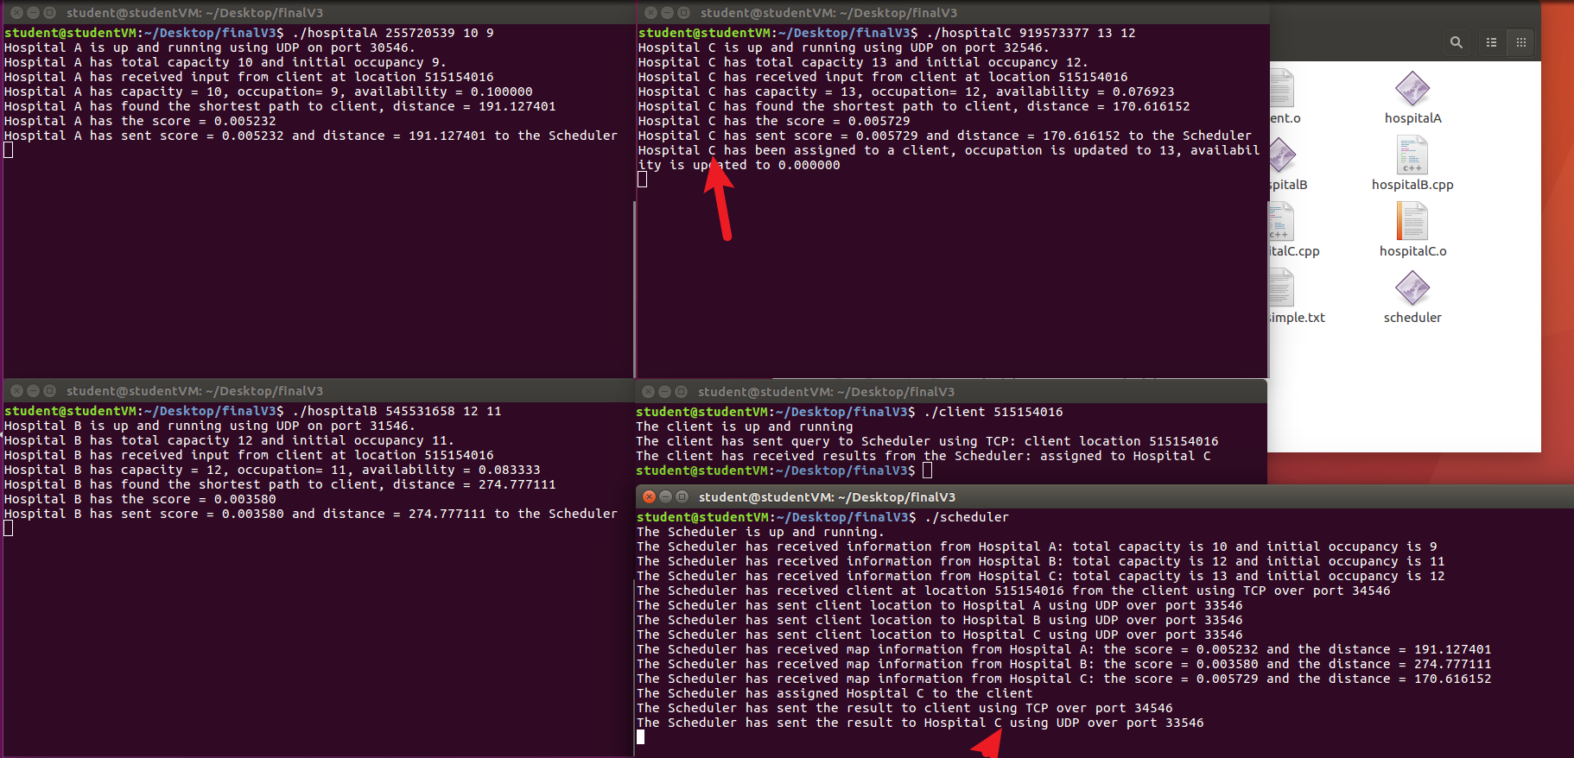

## Debug3

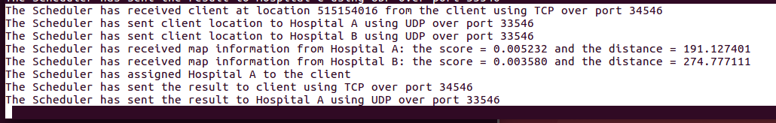

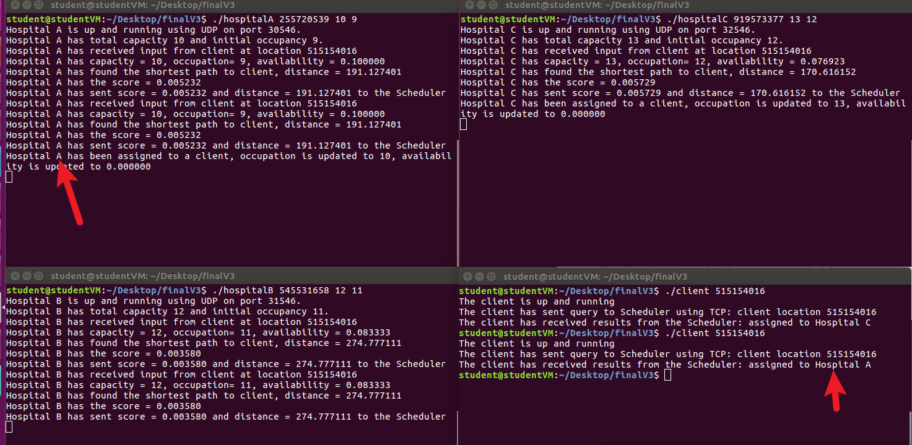

## Debug4

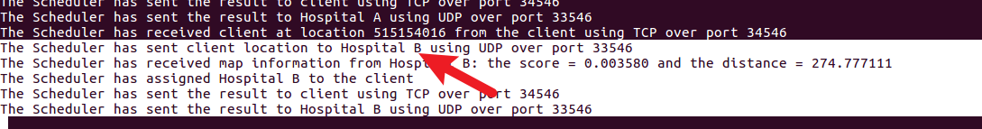

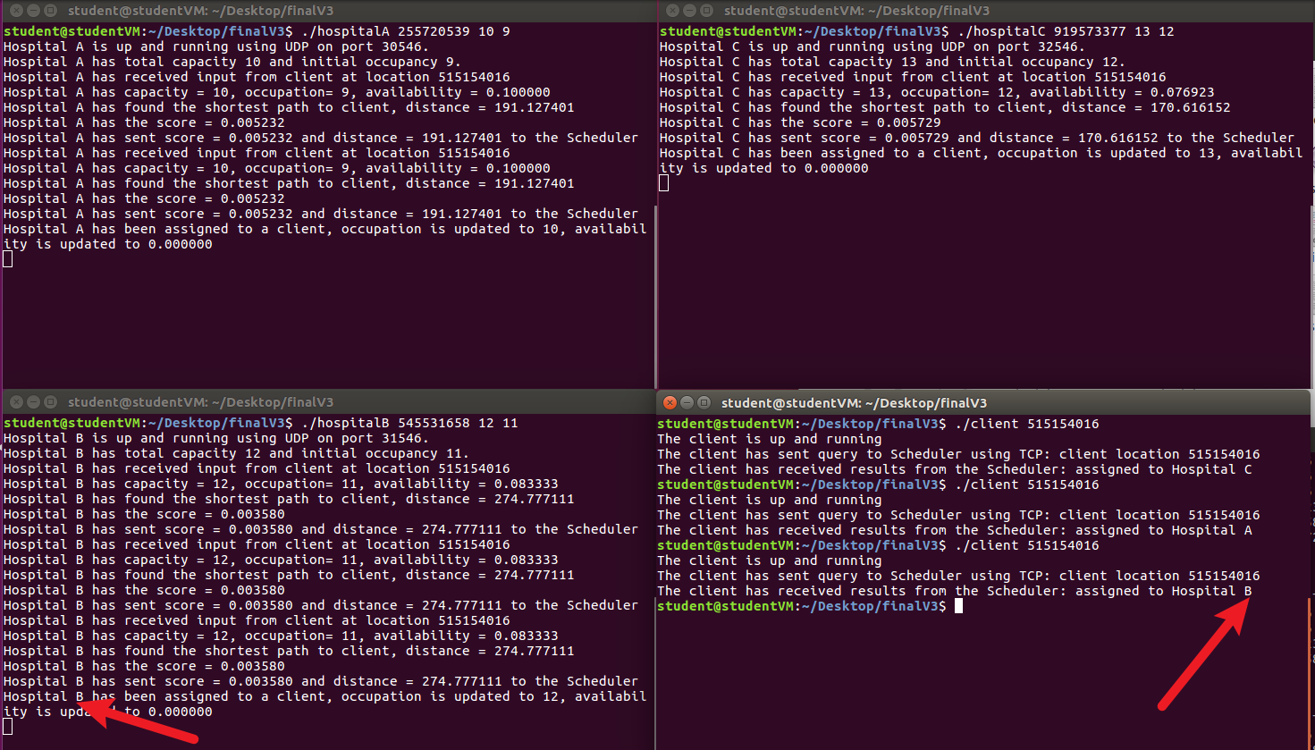

## Debug5



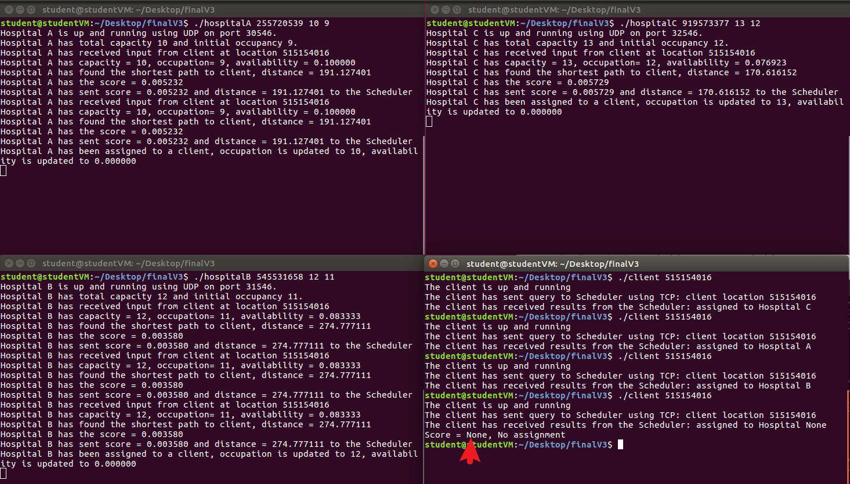

# make file

## 上传：

cd Desktop/finalV1

tar cvf ee450_chengzhi_session1.tar *

gzip ee450_chengzhi_session1.tar

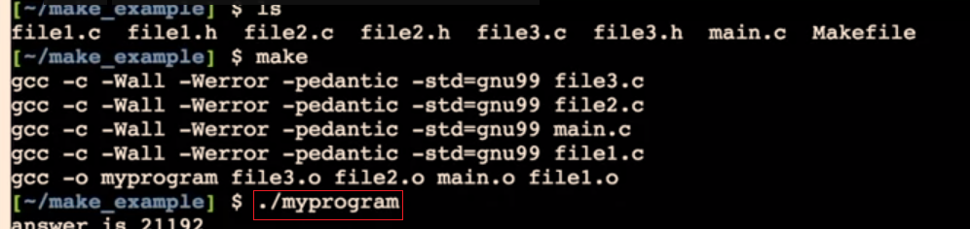

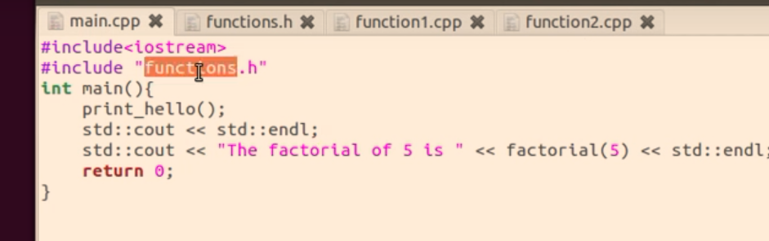

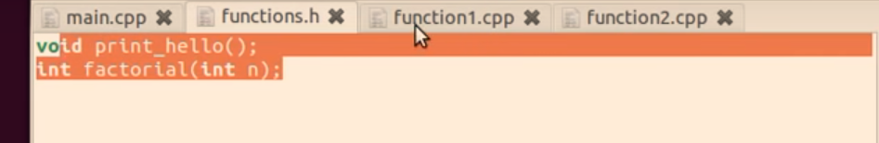

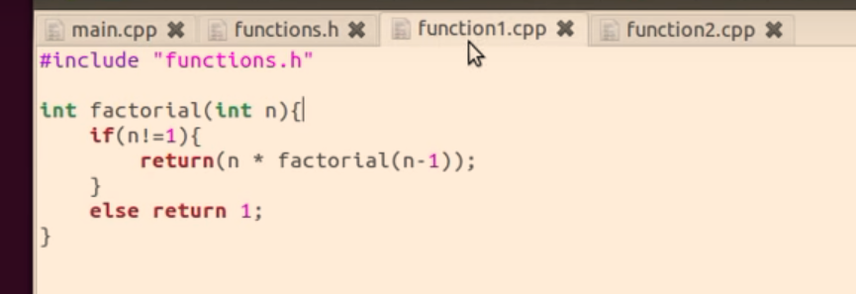

cd Desktop/mymake

g++ scheduler.cpp hospitalA.cpp hospitalB.cpp hospitalC.cpp client.cpp -o hello

g++ -std=c++0x scheduler.cpp hospitalA.cpp hospitalB.cpp hospitalC.cpp client.cpp -o hello

**g++ -std=c++0x client.cpp -o client**

